**Access Hotel System**



***Use Case Specification Document***

**Access Hotel System**

**Version No. 1**

**Project Document Revision History**

|  |  |  |  |
| --- | --- | --- | --- |
| **Version**  **#** | **Date** | **Revision Author** | **Description of Revision** |
| 1 | 6/26/20 | Khalid Saeed | Initial Version |
|  |  |  |  |

|  |
| --- |
| **Table of Contents** |

**Introduction** **3**

**Use Case Information** **4**

Actors 4

Use Case Interaction 4

**Trigger** **5**

**Pre-condition(s)** **5**

The Employee must be successfully able to access the hotel management system (via Access Hotel System use case) and verify a reservation exists. 5

**Post-condition(s)** **5**

The status of a reservation is changed 5

**Use Case Swimlane (Activity) Diagram** **5**

**Main/Basic Flow(s) of Events (Happy Path)** **6**

Access a reservation 6

**Alternate/Exception Flow of Events** **6**

**Assumptions/Business Rules including Non-Functional Requirements** **6**

**Use Case Specification Review and Signoff** **6**

# **Introduction**

This document captures detailed functional and non-functional BUSINESS requirements. Technical or application IT requirements should not be detailed here. A separate Use Case Summary document ties ALL the individual use cases together. First create the Use Case Summary document using application decomposition. Then increase the detail by creating the individual use case specifications – be careful not to create too many or not create enough use cases.

The hotel guests to create, edit, and use their accounts via accessing the hotel system. Guests will be able to create an account for themselves. They will also be able to modify the account and have access to a method which allows the user to gain access to their account. They can also check their login information and view and edit their names and locations.

# **Use Case Information**

## **Actors**

An actor is someone or something (e.g. application system) outside the system or business that interacts with the application. For every Use Case, there must be at least one Main Actor and zero or more Secondary Actors. Actors should be a person, system, or time.

|  |  |  |
| --- | --- | --- |
| Actor Name | Role | Description |
| Customer | Main | Primary Actor: Interacts with the system to create, login, logout, modify, and view their account. They can also view and modify user login information which consists of name and location. |
| Employee | Main | Primary Actor: interacts with system to cancel and review reservations, create accounts for customers, view summary reports and hotel informatics, and manage the hotel and other various functions |
| System | Secondary | Secondary Actor: interacts with the system to check if user credentials are valid. Also, provides information relative to users’ accounts. |
| Hotel Management System | Secondary | Interacts with the system to store user information data such as name and location. Information is also presented back to the customer. |

## **Use Case Interaction**

How does this use case relate to other uses cases? List predecessor and successor use cases.

**Successor Use Cases**

* Hotel Management System
  + Employee must manage Hotel and Hotel locations .Employee checks on the availability of and unavailability of rooms in a hotel.
* Reservation
  + A reservation needs to exist before checking in/out.
* Check-in / Check-out
  + A check-in or check-out to a hotel room requires a successful reservation and payment to occur first.
* Rewards
  + If a customer, may view and manage their reward points.

**Predecessor use Cases**

* N/A

# **Trigger**

* Employees can enter login credentials. If login credentials are correct, he may manage accounts and or access the system. Else, they must go through forgotten password process.
* Customer attempts to enter the system. If the customer has an account, they may log in to view information or edit information. Else, they have access to creating an account.

# **Pre-condition(s)**

What use cases or other pre-conditions must be met before use can initiate?

* Employee and Customer profiles must be defined and created
* Once an account is created, user login information must match previously entered credentials.

# **Post-condition(s)**

What are ALL the possible output states upon completion of the use case flows?

1. Create account
   1. User creates account consisting of username and password.
2. Modify Account
   1. Change username and or password. Also, able to view and change name and location.
3. Forgot user credentials
   1. Successfully resetting password.
4. User login/logout
   1. Allow user to login/logout of the system.

# **Use Case Swimlane (Activity) Diagram**

Draw diagram(s) that cover ALL main and alternate flows.

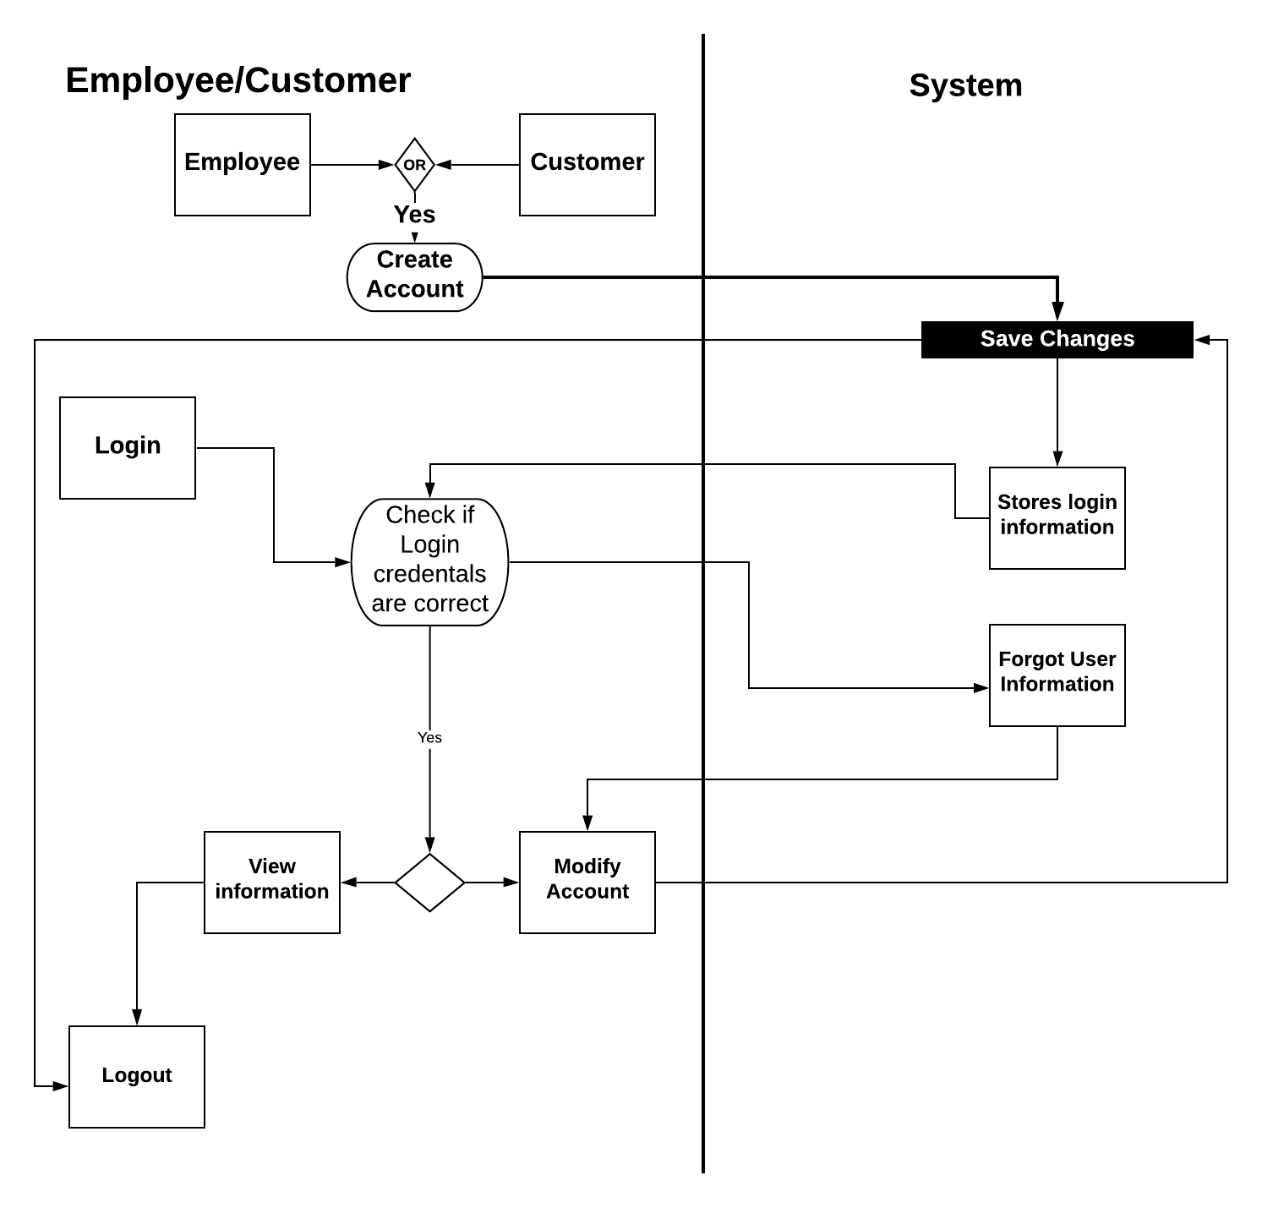

# **Main/Basic Flow(s) of Events (Happy Path)**

For each main flow (usually ONE flow) write the list of steps that occur – describe WHAT occurs not HOW to do it!

## **Access hotel system**

* + 1. The customer selects to create an account
    2. The customer selects to modify an account.
       1. Login to account with correct credentials
          1. Selects what to be modifies and modifies it. (Name and Location)
    3. Login to the account
       1. Check user credentials and verify with system to verify they are correct
       2. System records user login and displays to user recent activity
    4. Logout of the account.

# **Alternate/Exception Flow of Events**

For each alternative flow (can be zero or more) write the list of steps that occur – describe WHAT occurs not HOW to do it!

* 1. Forgot Password and cannot access account. Users must go through the forgotten password process.
  2. Users must enter a password again if they entered a wrong password.

# **Assumptions/Business Rules including Non-Functional Requirements**

Be sure to number the assumption/business rules to allow easy reference to them. Business rules will be where non-functional requirements are recorded – have a way to specifically identify non-functional requirements.

**N/A**

# **Use Case Specification Review and Signoff**

|  |  |  |  |
| --- | --- | --- | --- |
| Review and Signoff of the Use Case Specification | | | |
| Name | Project Team Role | Signature | Date |
| Peter Schubert | Team Lead/ Software Developer | PS | 6/26/20 |
| Jeffrey Fishman | Software Developer | JF | 6/26/20 |
| Monier Abdullah | Software Developer | MA | 6/26/2020 |
| Khalid Saeed | Software Developer | KS | 6/26/2020 |